BANK LOAN OF CUSTOMERS



PRESENTED MODULES

POWER BI TABLUE EXCEL SQL PYTHON

# PROJECT OVERVIEW



###### The aim of this data analytics project is to analyze customer bank loan data to uncover patterns, trends, and insights that can assist in improving loan portfolio management, risk assessment, and customer targeting strategies. The project focuses on key performance indicators (KPIs) that provide a detailed understanding of loan behaviors across different segments.

To effectively visualize and interpret the data, we created interactive dashboards using the following tools:

###### Excel, Tableau, and Power BI . These dashboards allowed for a

dynamic and detailed exploration of the data, providing actionable insights that can be easily communicated to stakeholders.

OUR MODULES

EXCEL

Excel was used for initial data exploration, including calculating summary statistics like averages, totals, and distributions.

Pivot tables and charts in Excel were employed to create quick visualizations of year-wise loan amounts and other KPIs.

SQL was used to query the bank's database and extract relevant loan data for analysis.

Complex queries were written to filter, join, and aggregate data from multiple tables.

Data was cleaned and structured in SQL to ensure it was ready for further analysis in other tools.

##### TABLEAU



A data visualization tool used for creating advanced visualizations and interactive dashboards.

Tableau's ability to create interactive visualizations helped in exploring the data more comprehensively and identifying hidden patterns.

Power BI was used to develop interactive reports and dashboards.

The tool’s capabilities in handling large datasets and creating dynamic visuals.

Power BI's integration features allowed for combining data from various sources, enhancing the overall analysis.





# KPI’S USED

#### KPI-1: Year wise loan amount Stats.

KPI-2: Grade and sub grade wise revol_bal.

#### KPI-3: Total Payment for Verified Status Vs Total Payment for Non Verified Status.

KPI-4: State wise and last_credit_pull_d wise loan status.

#### KPI-5: Home ownership Vs last payment date stats.



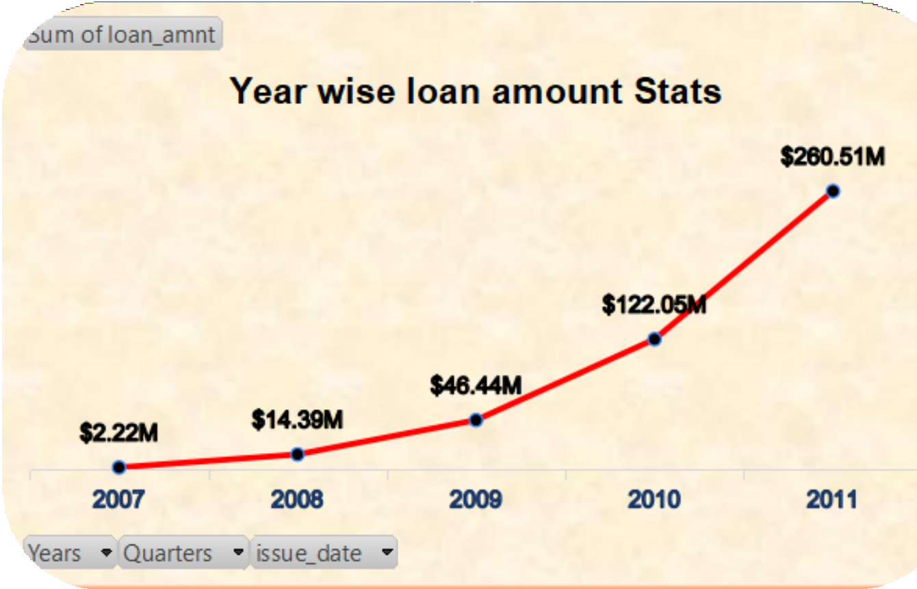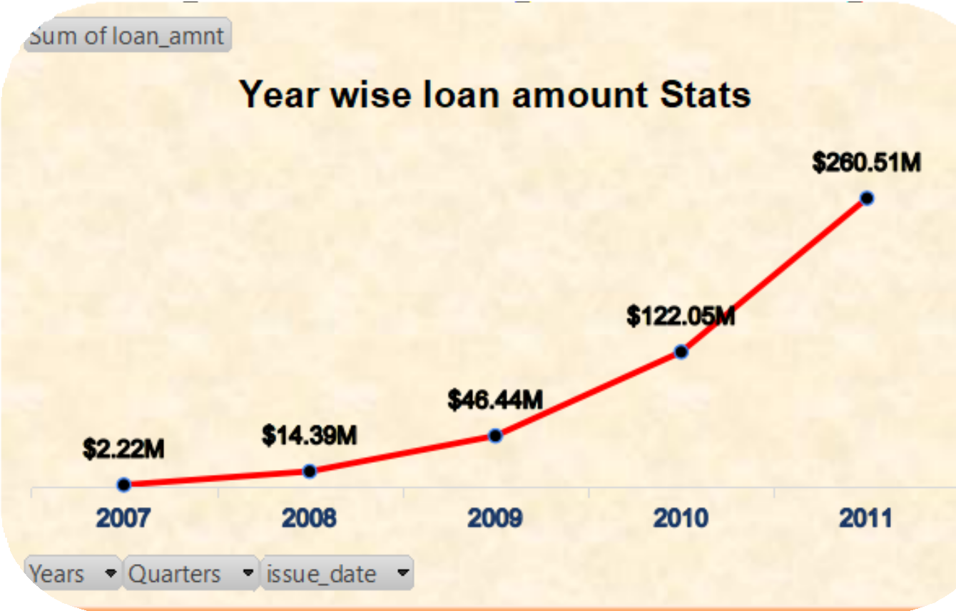

KPI-1 YEAR WISE LOAN AMOUNT STATS

A line graph that shows the **Year-wise Loan Amount Statistics** for the years 2007 to 2011. The graph illustrates the sum of loan amounts issued each year.



Trend: The graph shows a clear upward trend, with loan amounts growing exponentially each year.

Growth: The most significant growth occurred between 2009 and 2011, indicating a rapid expansion in the loan portfolio during these years.



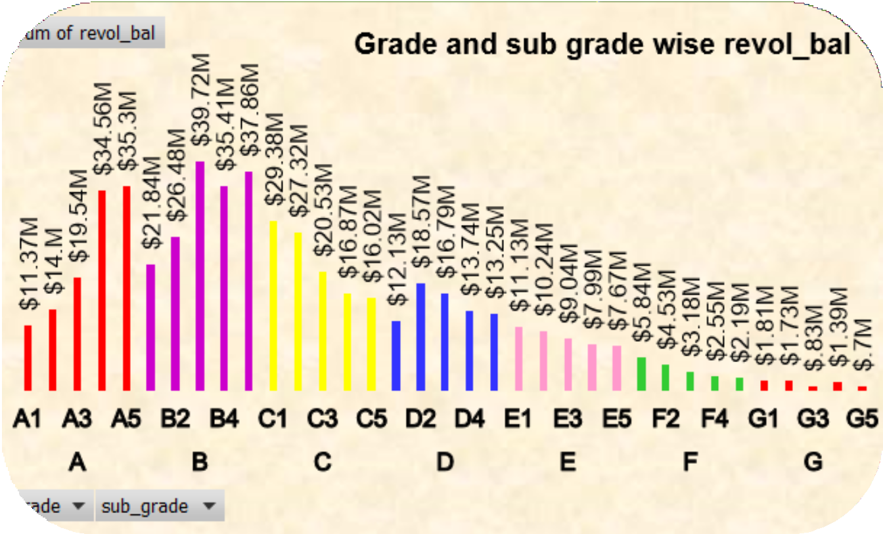

KPI-2 GRADE AND SUB GRADE WISE REVOL_BAL.

The bar chart "Grade and sub grade wise revol_bal." It visualizes the sum of "revol_bal" (which likely refers to revolving balance, such as outstanding credit card balances) for various grades and subgrades.

Subgrades in grade B (B2, B4) have the highest

revolving balances, with B4 having the highest ($39.72M).

* The revolving balances decrease as we move from grade A to G, with subgrades in grade G having the lowest balances.
* Grade G subgrades have significantly lower revolving balances compared to other grades.

KPI-3 TOTAL PAYMENT FOR VERIFIED STATUS VS TOTAL PAYMENT FOR NON VERIFIED STATUS.

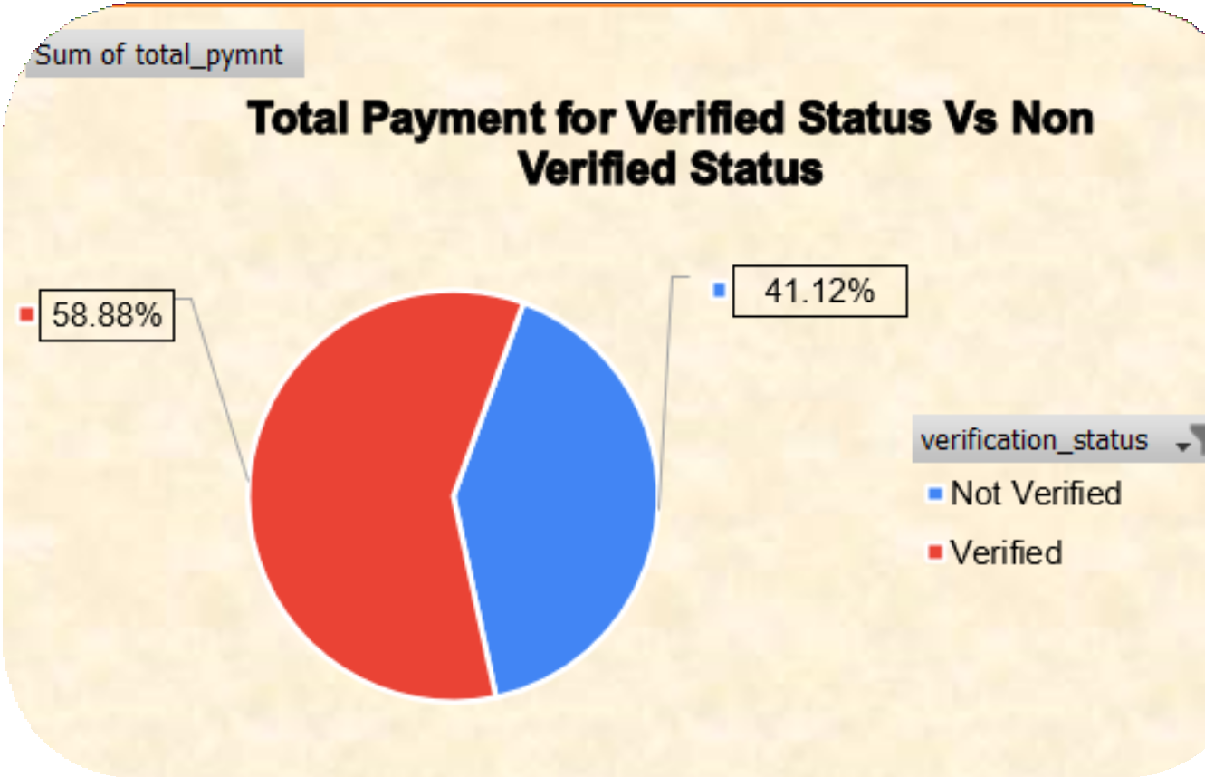

The chart illustrates the distribution of total payments made by customers based on whether their status was verified or not.

The larger portion of total payments, 58.88%, comes from customers whose status was verified. This suggests that verified customers are more likely to make higher or more consistent payments compared to non-verified customers.

Non-verified customers still contribute a substantial 41.12% to the total payments, indicating that even without verification, a large portion of customers are fulfilling their payment.



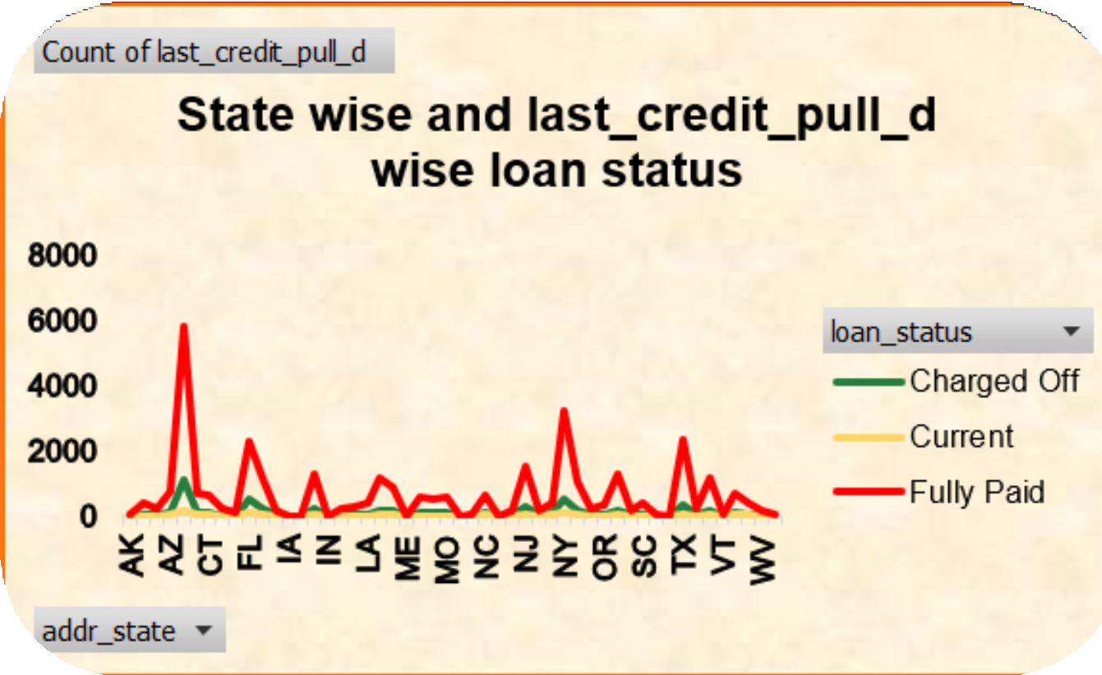

KPI-4 STATE WISE AND LAST_CREDIT_PULL_D WISE LOAN STATUS



This line graph showing the State-wise and Last Credit Pull Date-wise Loan Status. The graph plots the number of loans across different states in the U.S. based on their loan status, which includes "Charged Off," "Current," and "Fully Paid".

Some states, like California (CA) and New York (NY), show a higher number of loans.

In most states, there is a relatively balanced distribution between loans that are "Current" and "Fully Paid," with fewer loans being "Charged Off."



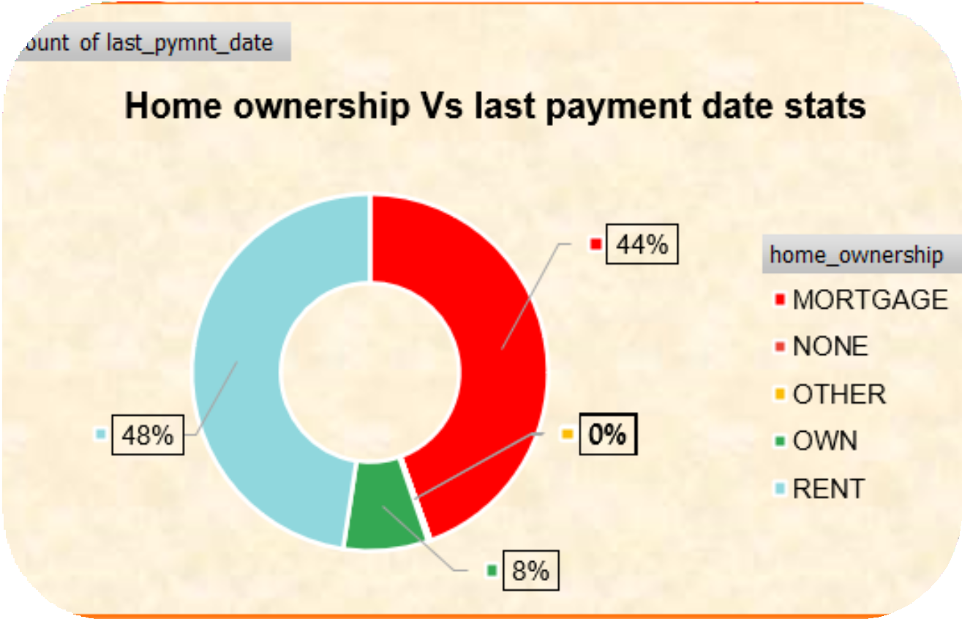

### KPI-5 HOME OWNERSHIP VS LAST PAYMENT DATE STATS.

This is a donut chart that visualizes the relationship between different types of home ownership and the last payment date. The chart shows the percentage distribution of these home ownership types.



This indicates that 44% of the last payment dates correspond to individuals with a mortgage, with 48% who are renting their home, 8% who own their homes outright.





DASHBOARDS

EXCEL DASHBOARD

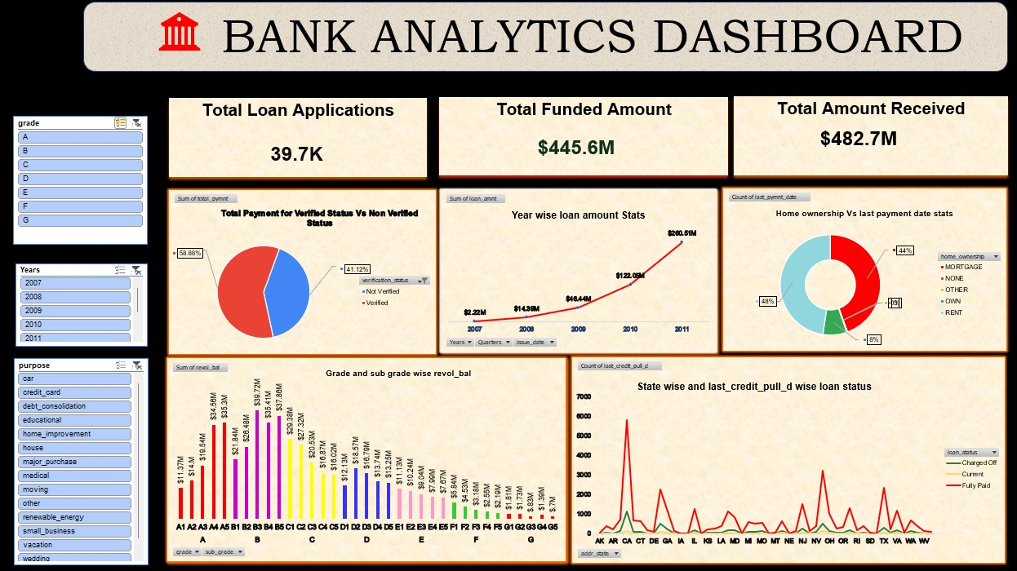

MYSQL QUERIES

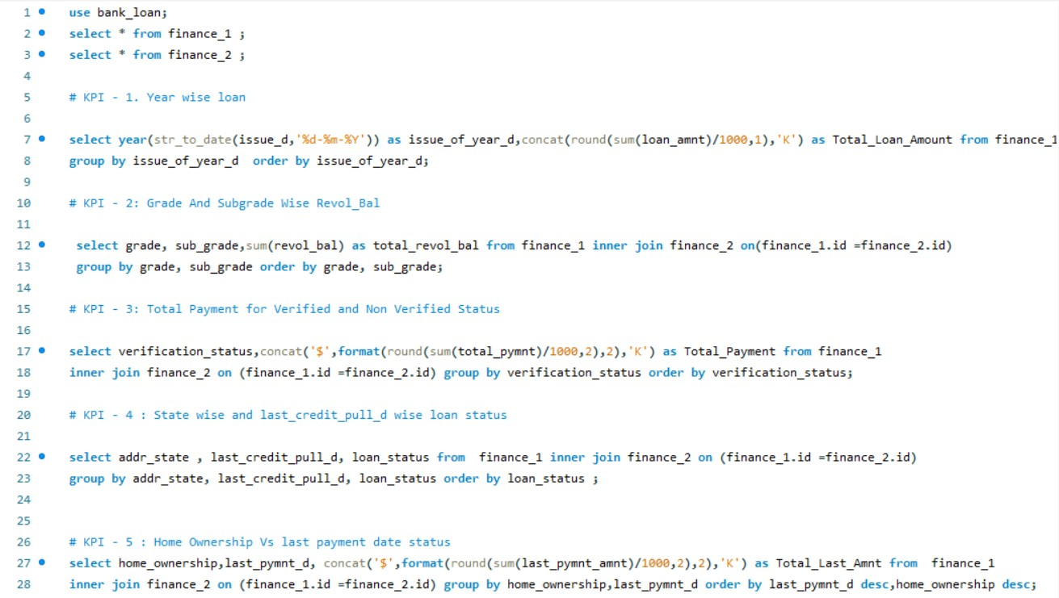

## TABLEAU DASHBOARD

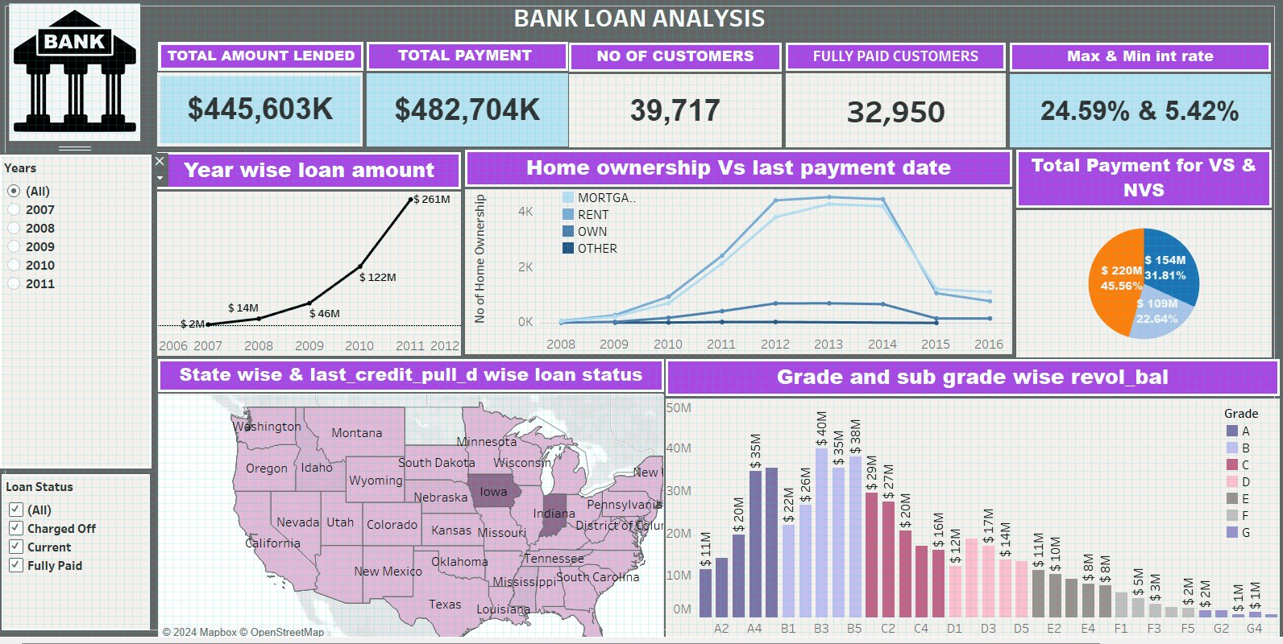

POWER BI DASHBOARD

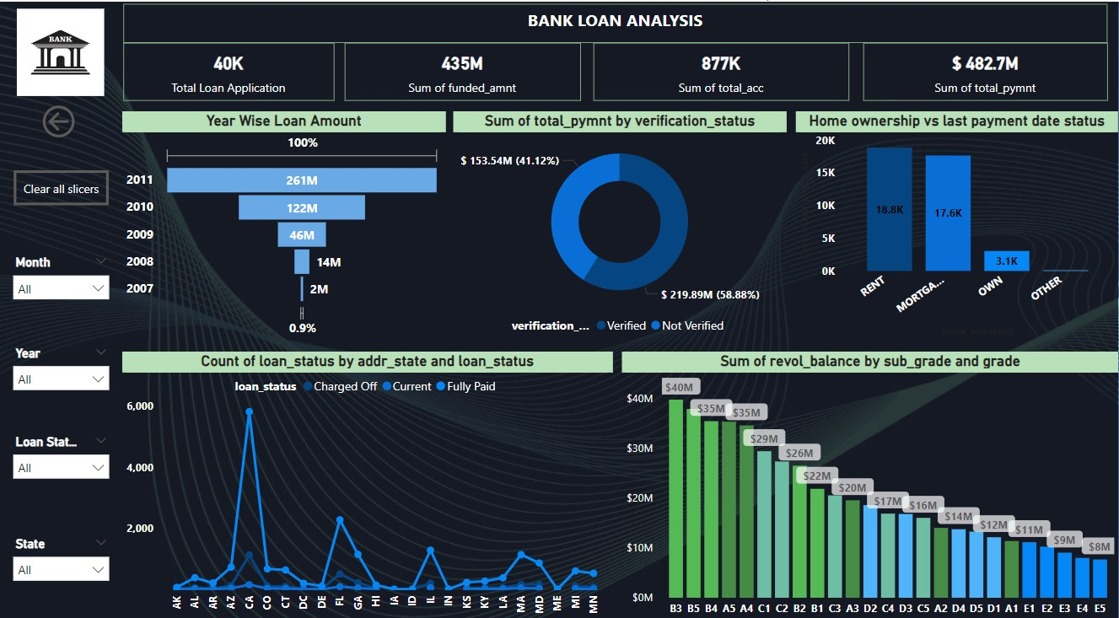

CONCLUSION



###### The project has successfully uncovered significant trends and patterns in the bank's loan portfolio, offering actionable insights that can be used to refine lending strategies, enhance risk management, and improve customer targeting. The use of tools like Excel, Tableau, Power BI, and SQL was critical in preparing comprehensive dashboards that facilitate informed decision-making.





THANK YOU